**MESD Documentation LMS-45-Surveys-engine**

**Purpose**

To allow for users to create surveys to elicit feedback from participants.

**Background**

The surveys engine is an integral part of the LMS it will be the sole module of the application that allows for information to be gathered through the means of questionnaire or survey. There a re two types of surveys in the LMS the fully automated survey tool which has pre-defined surveys and the custom feedback activity which allows for users to generate surveys to best fit their criteria.

**The Survey Activity**

* The Survey activity offers a number of verified survey instruments, including COLLES (Constructivist On-Line Learning Environment Survey) and ATTLS (Attitudes to Thinking and Learning Survey), which have been found useful in assessing and stimulating learning in online environments. Teachers can use these to gather data from their students that will help them learn about their class and reflect on their own teaching.
* Note that the Survey is not customisable; if you want to create your own survey questions, then explore the [Feedback activity](https://docs.moodle.org/403/en/Feedback_activity).

[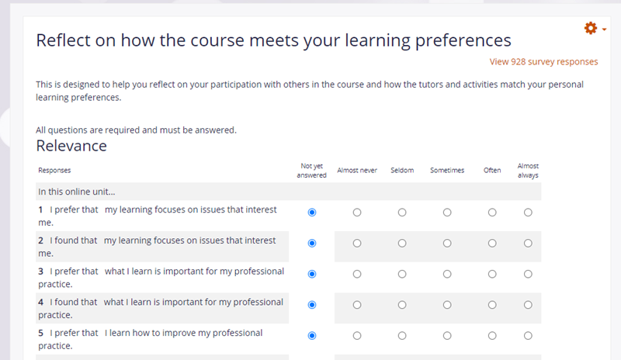](https://docs.moodle.org/403/en/File:NewSurveyExample.png)

**How is it set up?**

1. In a course, with the editing turned on, choose 'Survey' from the activity chooser.
2. Give it a name and, from the dropdown, choose your Survey type. Click the question mark ? icon for information about each Survey type.
3. Add a description if required.
4. Expand the other sections to select the settings you need.
5. Click Save and return to course.

**How does it work?**

**Student view**

Students click on the Survey icon in the course to access it and click the appropriate radio buttons next to the statements. When they have finished, they are able to see how their responses compare to the average of the class.

[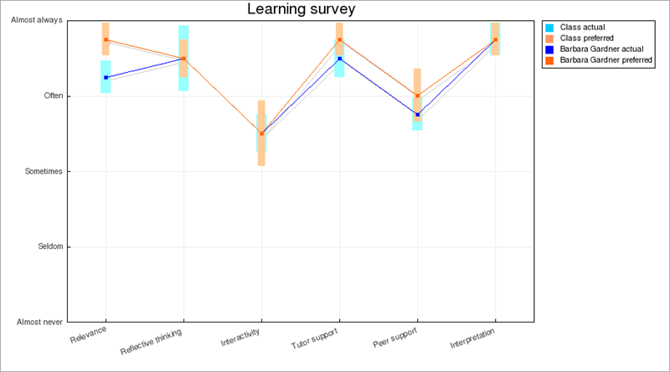](https://docs.moodle.org/403/en/File:StudentSurveyResults.png)

**Teacher view**

When teachers click the Survey icon, they can view results by clicking the link 'View ... survey responses' or by clicking Response reports from the gear icon Action menu. They have a number of tabs providing different data.

[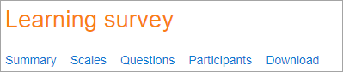](https://docs.moodle.org/403/en/File:TeacherSurveyResults.png)

**Feedback activity**

The Feedback activity allows you to create and conduct surveys to collect feedback. Unlike the [Survey](https://docs.moodle.org/403/en/Survey_module) tool it allows you to write your own questions, rather than choose from a list of pre-written questions and unlike the [Quiz](https://docs.moodle.org/403/en/Quiz_module) tool, you can create non-graded questions. The Feedback activity is ideal for course or teacher evaluations.

**How is it set up?**

1. In a course, with the editing turned on, choose 'Feedback' from the activity chooser.
2. Give it a name and if required, a description
3. Expand the other sections to define the settings you want, in particular Question and Submission settings and what to display After submission.
4. Click Save and display and from the Edit questions tab, Add question drop down, add the questions you want.

**How does it work?**

**Student view**

Students click on the feedback icon in the course to access the activity and then must click the button *Answer the questions*.

[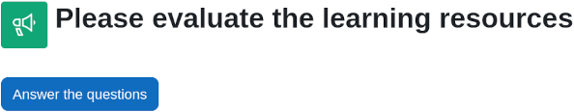](https://docs.moodle.org/403/en/File:feedbackstudent402.png)

**Teacher view**

Teachers see the *Settings* tab as well as an *Analysis* tab and *Responses* tab. Results may be exported to a spreadsheet program.

From the *Analysis* tab they see a report of the aggregate of responses, including a graphical display of answers to multiple choice questions.

From the *Responses* tab they see individual responses in detail.

[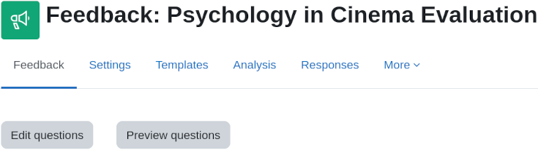](https://docs.moodle.org/403/en/File:feedbackteacher402.png)